# Exercise: Computer Systems and Software – MySQL, Workbench

Problems for exercises and homework for the ["Software Technologies" course @ Software University.](https://softuni.bg/trainings/4086/software-technologies-may-2023)

## What is it and why you need it

**MySQL Workbench** is a **visual tool for database design, management, and administration**, while **MySQL Server is the actual database management system** that **stores, manages, and retrieves data**. QA engineers need these tools to create, manipulate, and verify databases during testing, ensuring that the application's data-related functionalities work correctly and meet requirements.

## How to install

**1.** Navigate to the official download site <https://dev.mysql.com/downloads/installer/>. Choose your operating system and click one of the two download buttons. It doesn't if you choose mysql-installer-web-community or mysql-installer-community. They are quite the same. The first one downloads the files needed while installing them, the other pre downloads the files needed and then installs them.

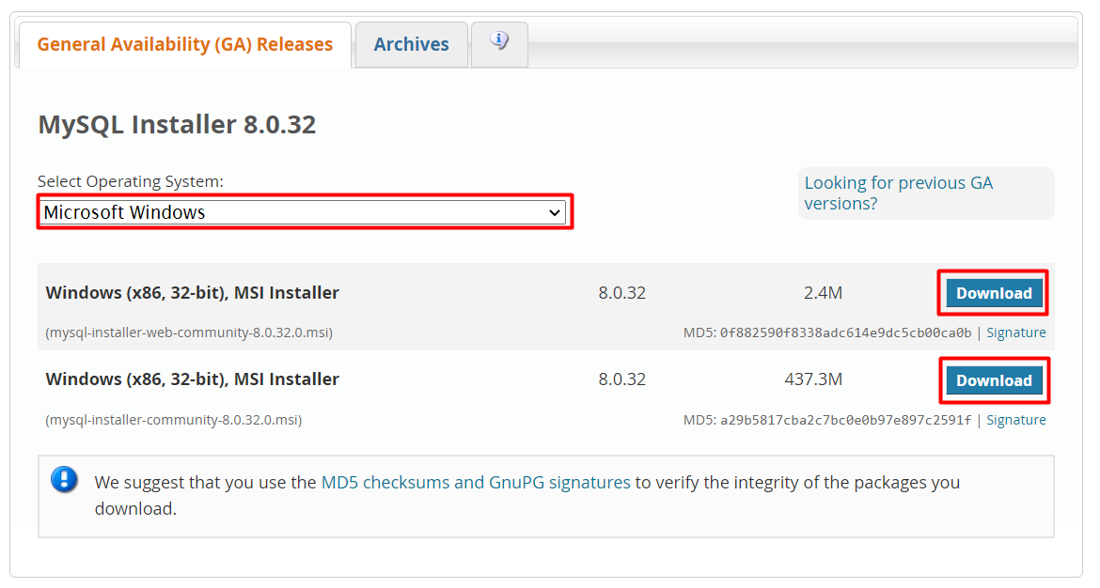

**2.** On the next page you will be prompted to Login or Sign up. Just skip this step.

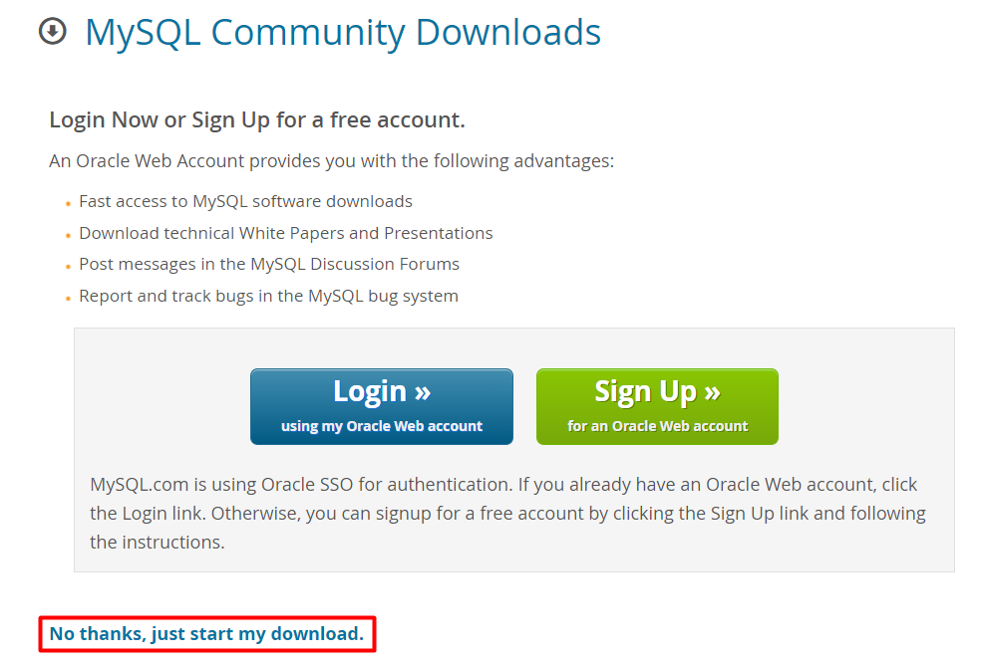

The .msi file will be downloaded to your browser.

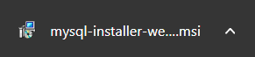

**3.** Open installation file and choose **Setup type** to be **Custom**. Then click **Next.**

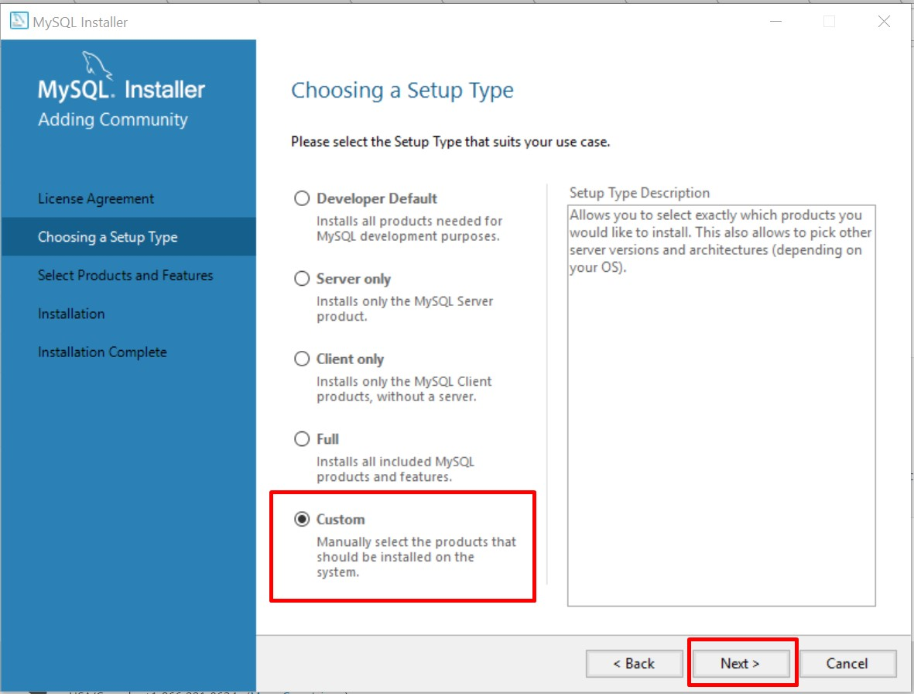

**4.** All the features we need are **MySQL Server**, **MySQL Workbench, Connector/J**, **Connector/NET and MySQL Workbench**. All other features are optional and won’t be needed for now.

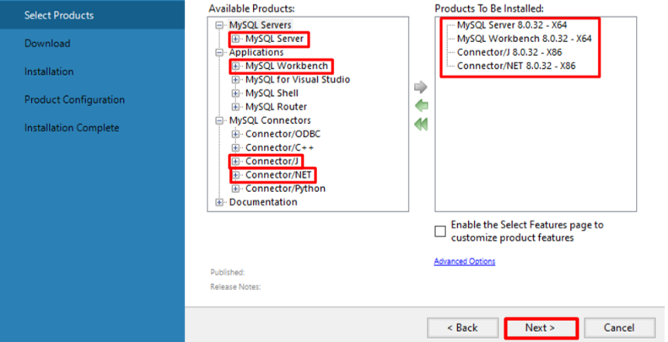

**5.** Click **Execute** and the setup will download the selected features.

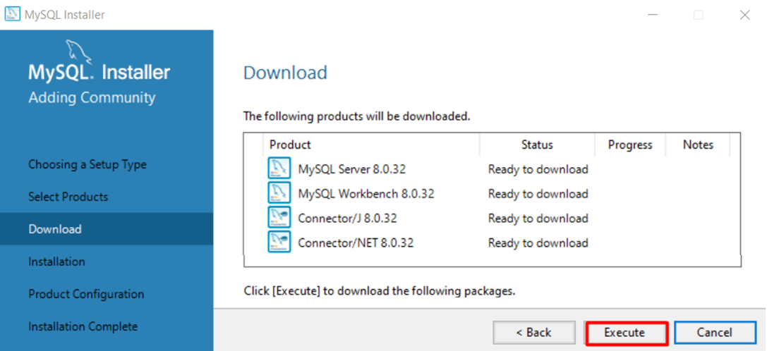

**6.** **Wait** for the downloads to complete. **Click Next**

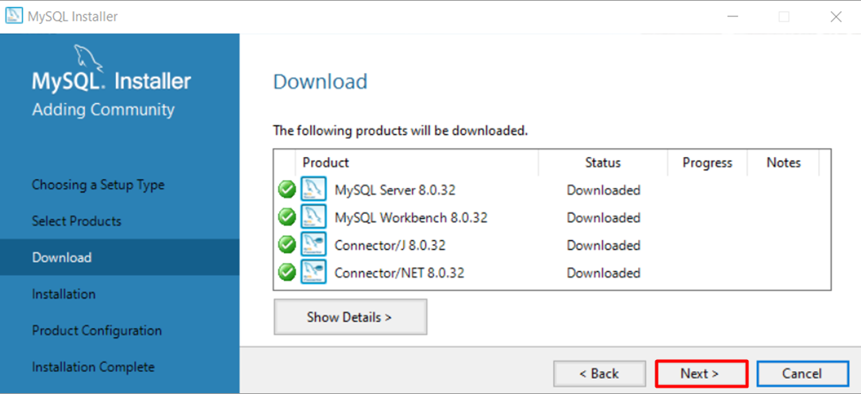

**7. Click Execute** to install the files.

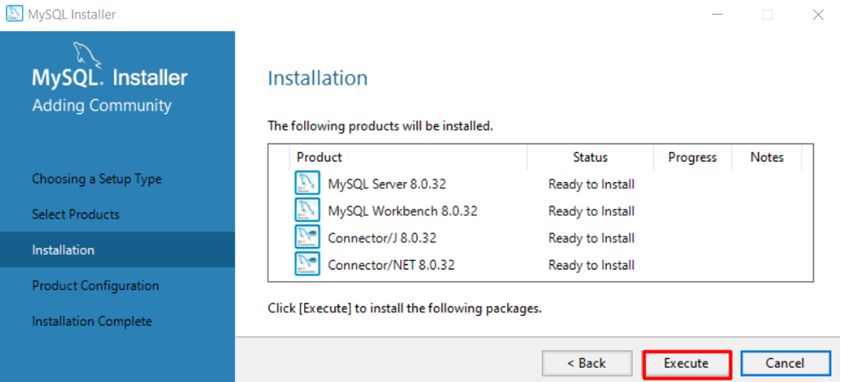

**8. Wait** for the **installation to complete and click Next** to start configuration wizard.

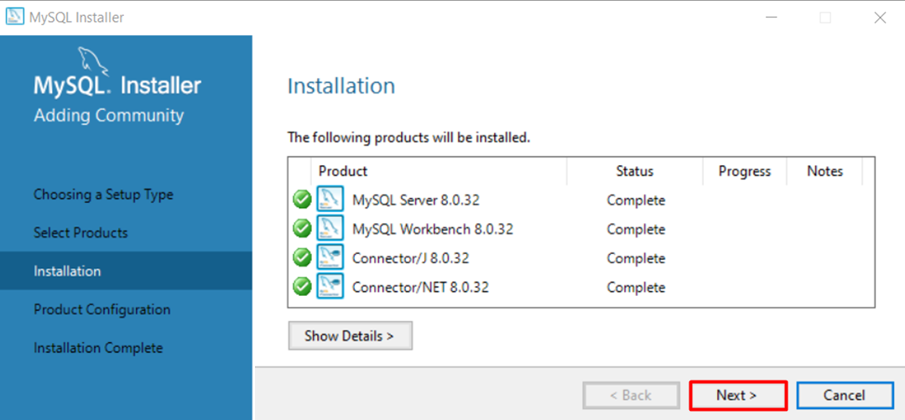

**8.** Now, you have to configure your product. Click Next.

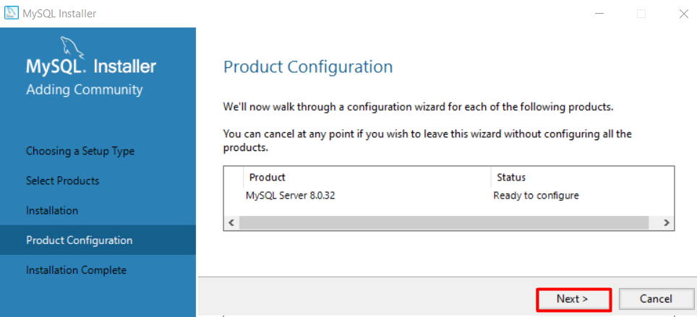  
**9.** Choose the configuration type to be a **Development Computer** and click on Next**.**

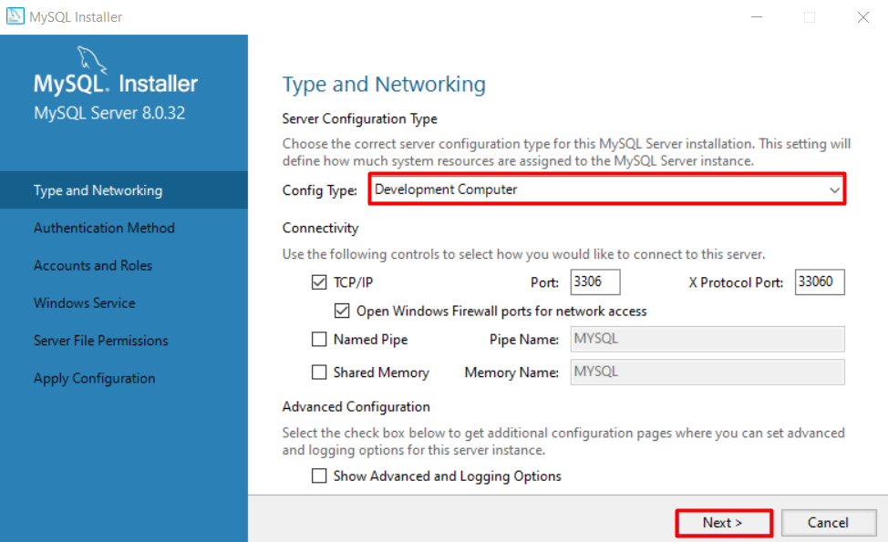

**10. Choose Authentication method** and click Next.

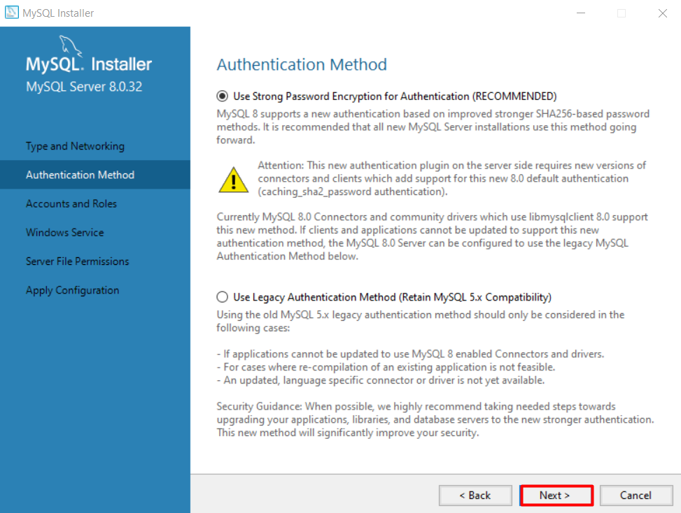

**11.** **Set password** to the Root account and click Next.

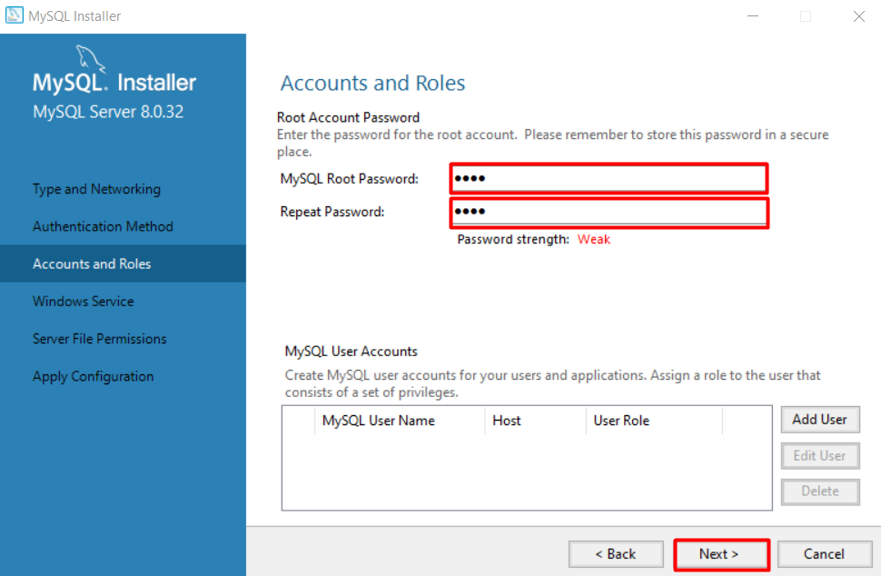

**12.** Here you can set the **MySQL Server to run as Windows Service and to start automatically at Windows start up**. Otherwise, **you must start up MySQL every time before working with a database**. Decide whichever suits you best.

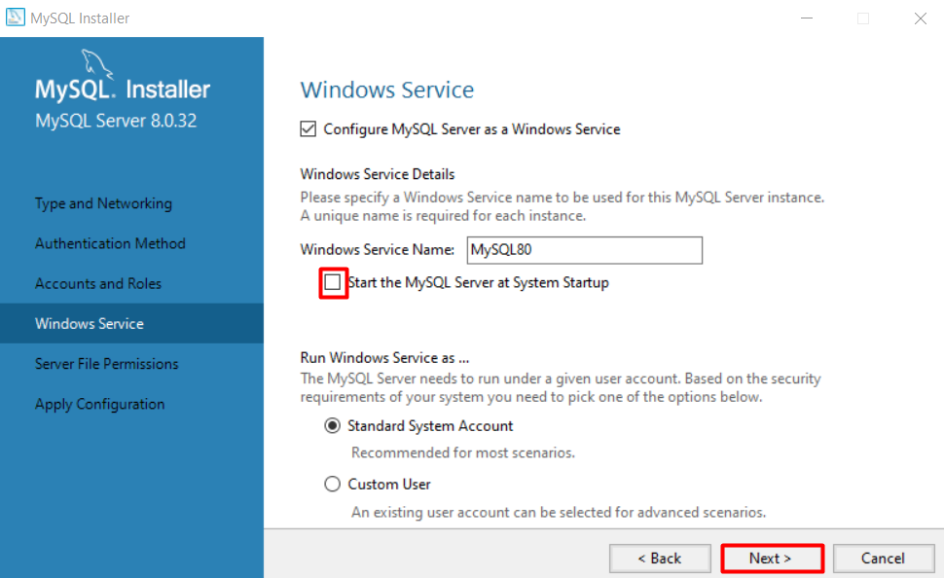

**13. Server File Permission –** Leave the chosen option as it as it is. Next.

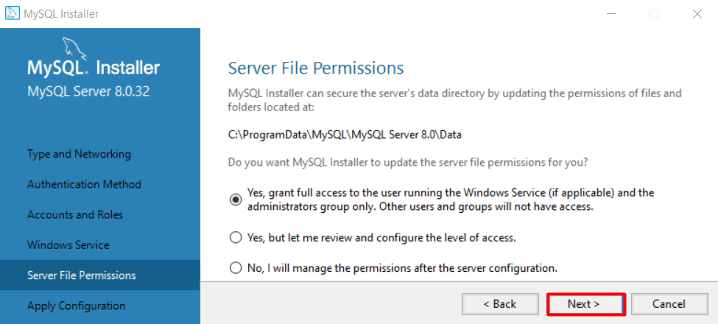

**14. Hit Execute** and wait for the **Configuration to be applied**.

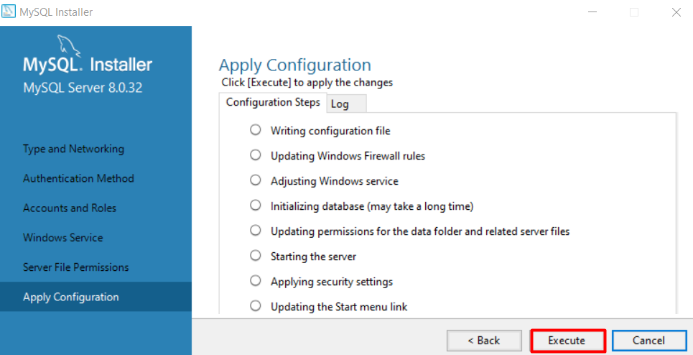

**15.** Click **Finish.**

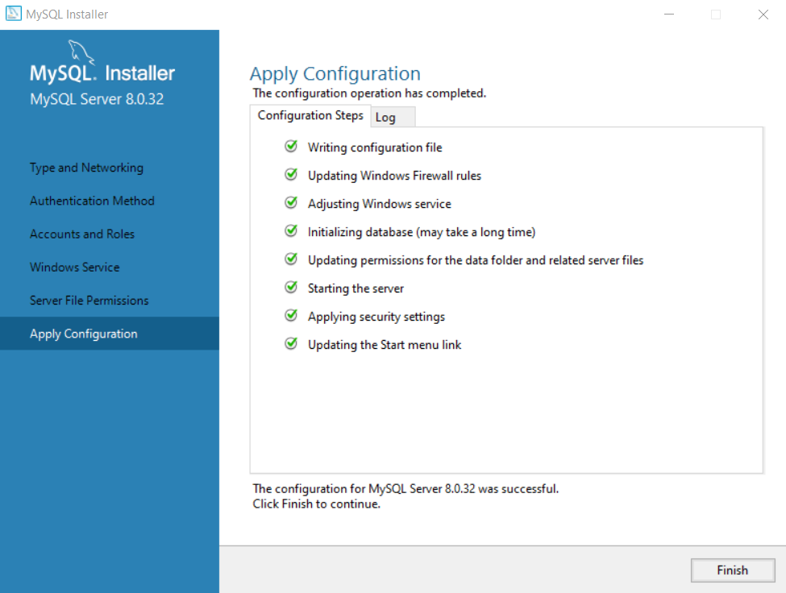

**16.** Another **Next**. 😊

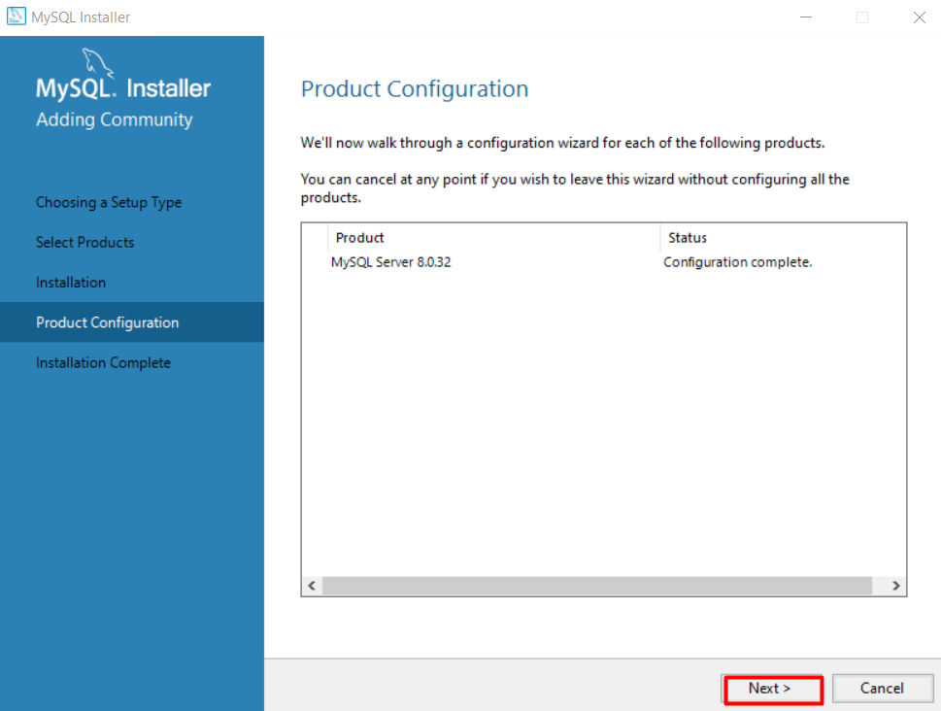

**17.** And one final **Finish.**

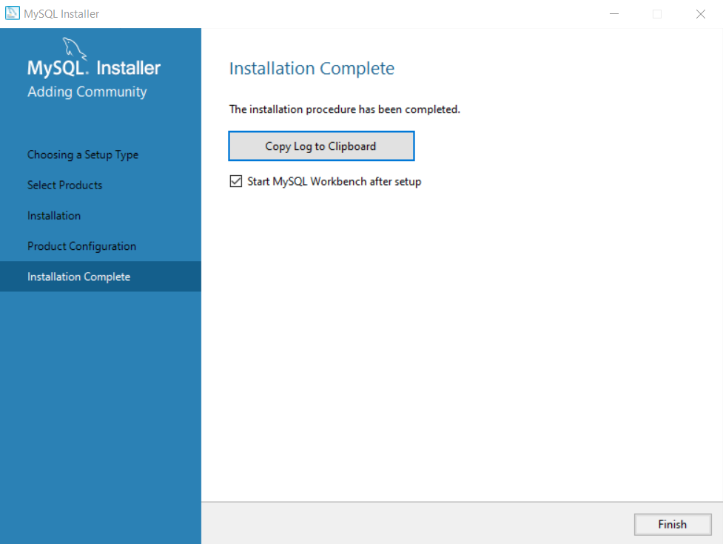

## Simple Database and queries

**1. Open Workbench and connect to the local server.**

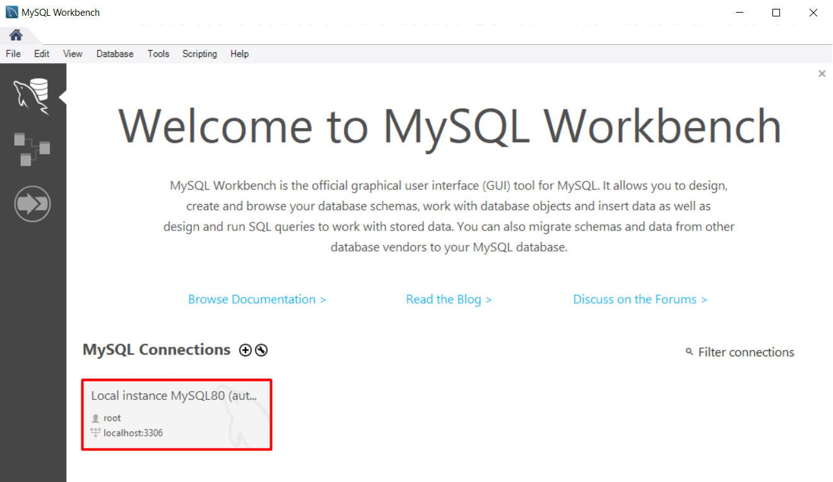

**2.** Enter the **password** you previously created.

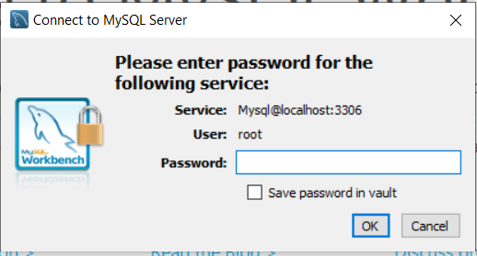

**3.** This is how **Workbench looks like**.

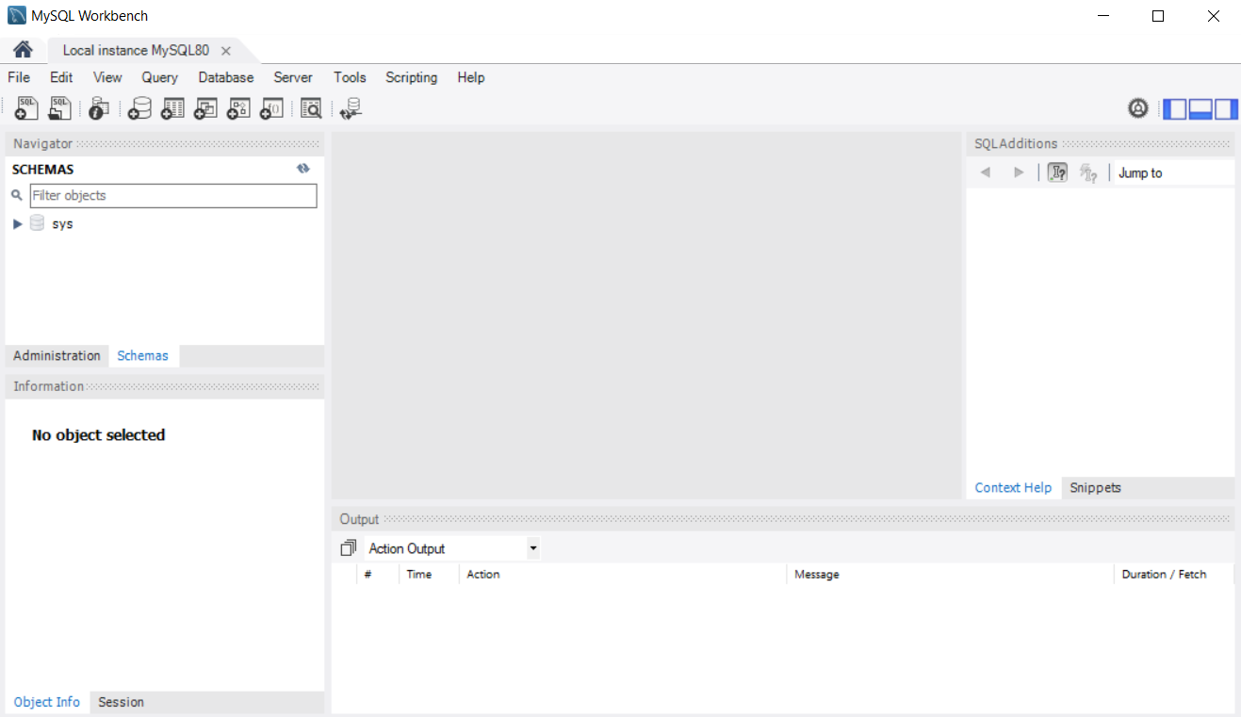

**4.** You can check the **status of your server** if you'd like.

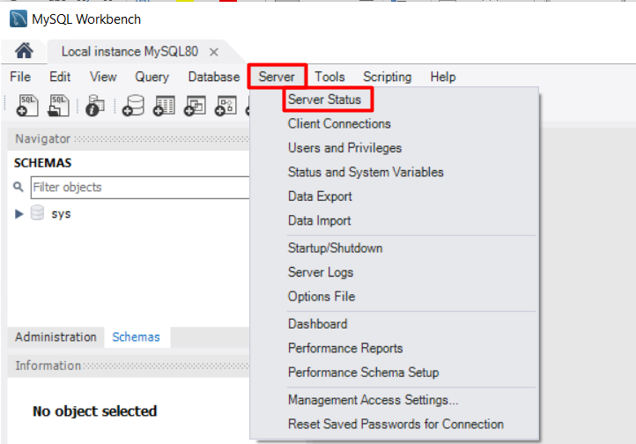

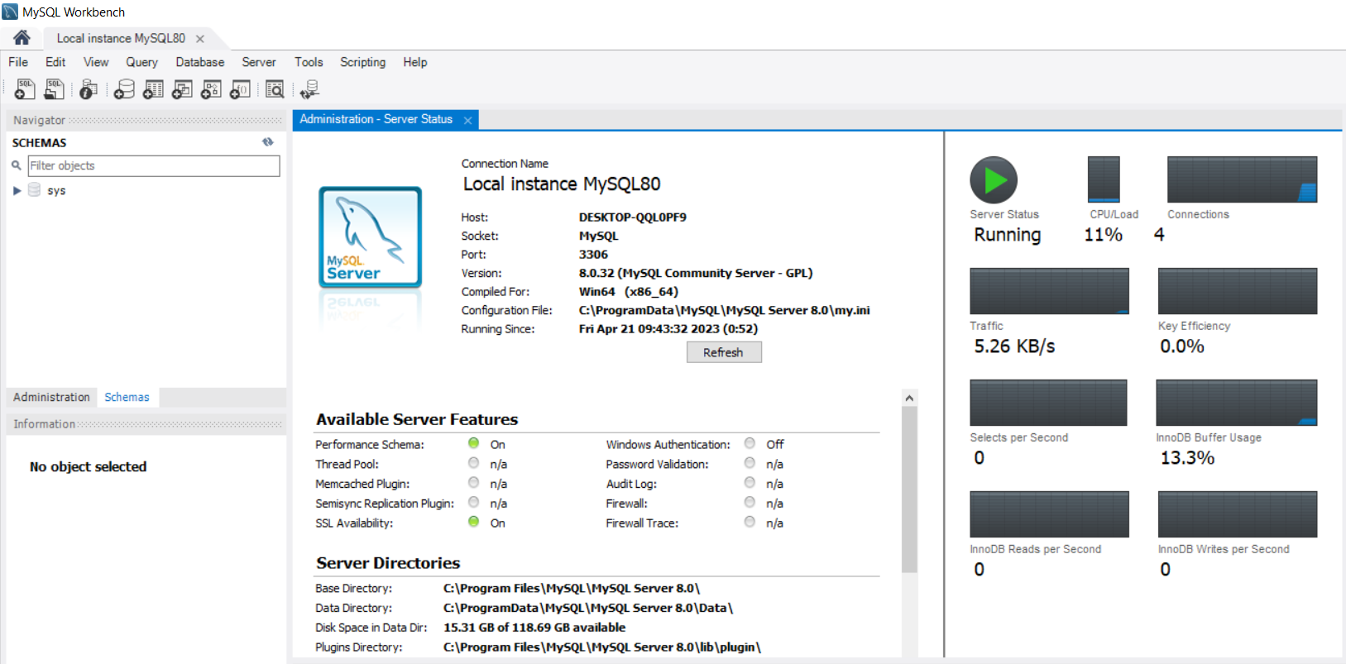

5. Now, we will open an existing SQL script, which will create a simple database, containing just one table and populate it with records. You are provided with the file "**01.Computer-Systems-and-Software-Exercise-MySQL-Database.sql**". You can open it in two ways:

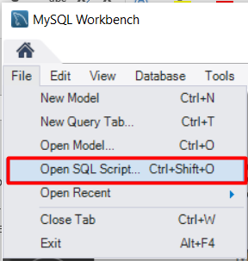 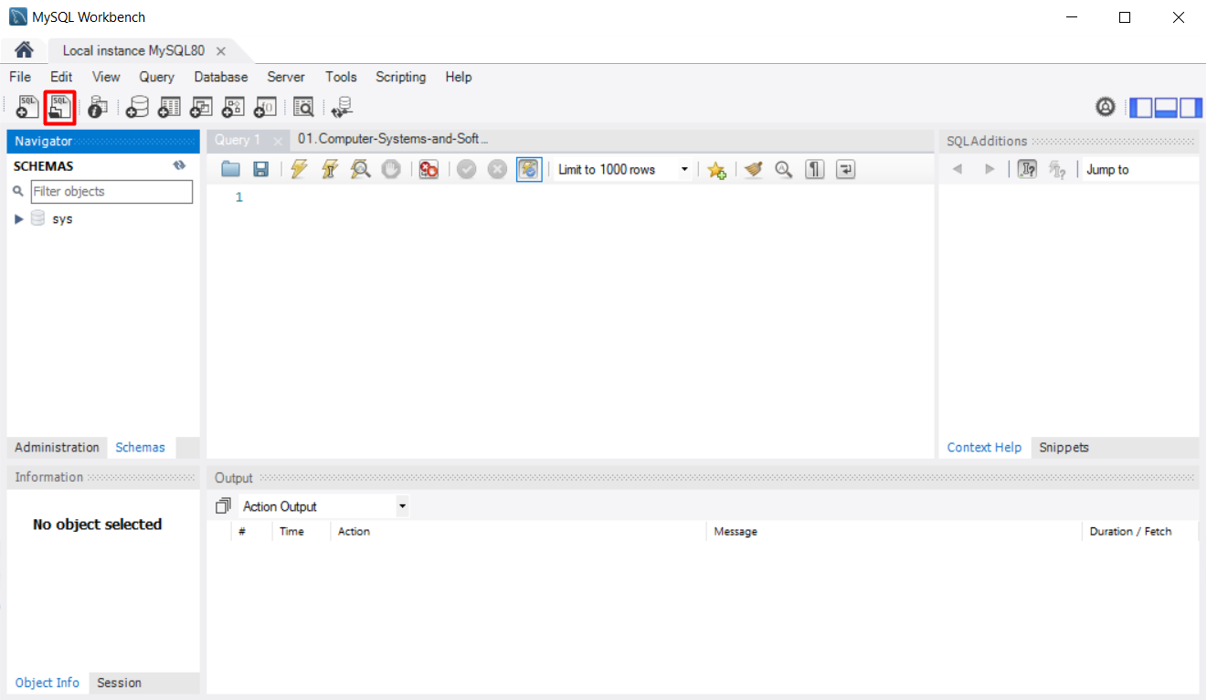

**6.** This is how the file **would look like** when you open it.

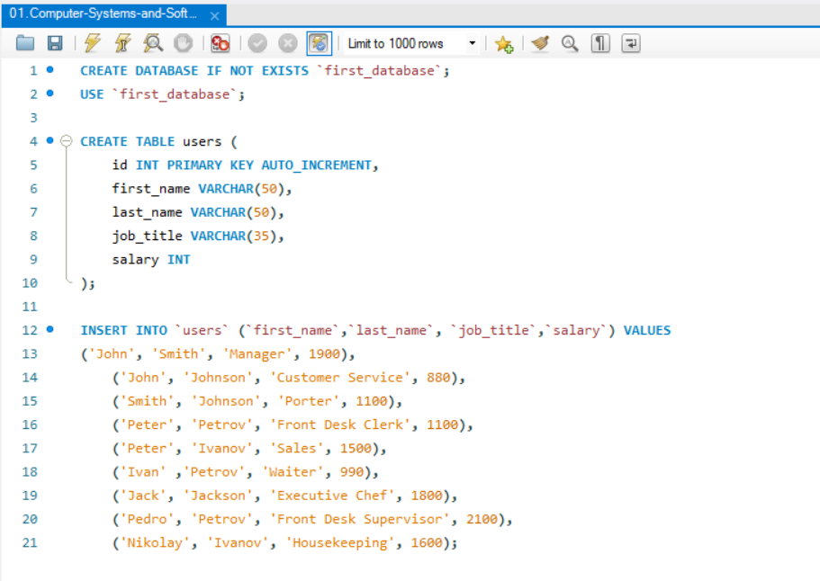

**7.** As you can see SQL is very logical and user friendly. The given script will create a database called "first_database" (if such database doesn’t already exist), then it will use the database to create a table "users" in it. Each user will have an id, first_name, last_name, job_title and salary fields. After creating the table, it will populate it with values.

In order to **run the script, hit the yellow bolt button**.

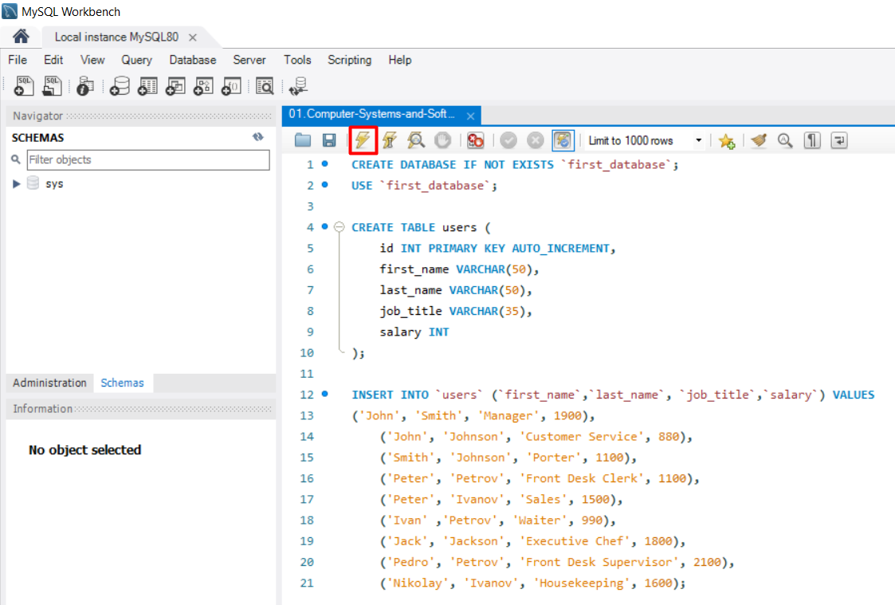

**8.** In the output section you should see the **commands executed.**

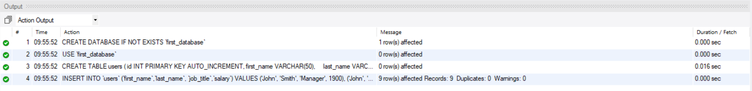

**9.** Hit the refresh button to **see** the **newly created database**.

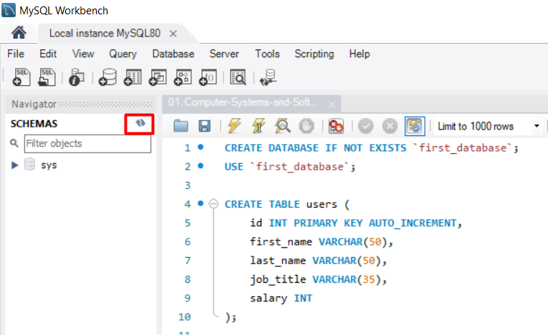

**10.** As you can see, the database was created with all it's attributes. Now, let's see how it looks like and write a few queries. **Click on the "Create a new SQL tab…" button.**

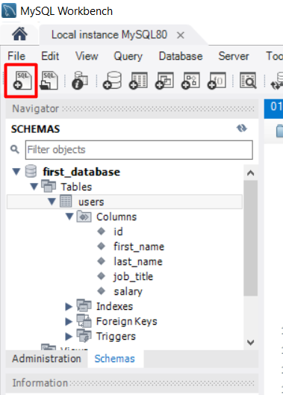

**11.** Now, we will **select all the records** from "users" table. Write the following query:

**SELECT * FROM users;**  
Now hit the other bolt button, which has something like an "I" sing on it.

**Note:** The difference between those two buttons is, as follows:

 - Executes the selected portion of the script or everything, if there’s no selection

 - Executes the statement under the keyboard cursor

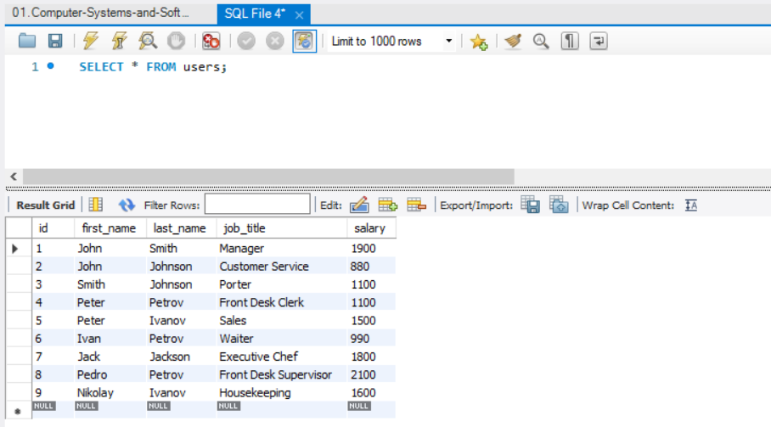

**12.** Now, that we know how all records looks like, let's execute a second **query**, which will select all records, where **salary is equal or more than 1500**.

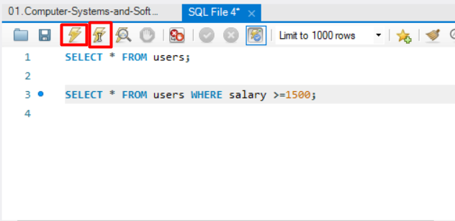

**13. Try a few queries by yourself.**

- Try to select all with last name "Petrov".

- Try to select all with first name "Peter".

- Try to select all with salary below 1800.